DEPARTMENT OF MONTANA
VETERANS OF FOREIGN WARS
2018 - 2019 MEMBERSHIP PROGRAM


“It Happened Here First”

MEMBERSHIP DRAWING
Any member who recruits ten (10) or more New, New Life or Reinstated Members will be eligible for three (3) cash drawings of $100.00 and one (1) cash drawing of $250.00 at the State Convention. Recruiters will receive (1) chance for every (10) members recruited Cutoff date April 30, 2019.

100% MEMBERSHIP PIN
Every Post Commander and Post Quartermaster who becomes 100% in Membership as recorded in the VFW on-line-membership system OMS, as of June 1, 2019 will receive a special 100% Membership Pin, Commander’s Pin, Montana Pin, and Commander-in-Chief Pin.

MEMBERSHIP

Each Post that reaches 100% in Membership by 31 December 2018 will be entered in a drawing for one of four $500 awards. Awards to be drawn at the Mid-Winter meeting.

Each District that reaches 100% in membership by 31 December, 2018 will receive $400 for your District.

Each District Commander is required to contact each Post monthly and send a monthly report to Department Headquarters identifying Posts contacted, person contacted and anticipated results of each contact in your efforts to get your Posts 100% in membership. The form is available from Department Headquarters and on the Department website at vfwmt.org.

Each Post or District Commander and Quartermaster that reaches 100% in membership by 5 May, 2019 will have their name placed into a drawing for a trip to Orlando, FL for the National Convention in July 2019 (Airfare and Hotel only).
This award is non-transferable and is void if the winner cannot attend the National Convention or is already being reimbursed by National to attend the convention.

All Posts and Districts that achieve 100% in membership by 5 May, 2019 will be entered into a drawing to win one of ten $250 awards for the Post or District.

TOP RECRUITER
Member who signs up the most New, New Life or Reinstated Members will receive a $250 gift certificate from the VFW store. State Headquarters will use information from the National Monthly Recruiter Report. Cut off date April 30, 2019.

ALL-STATE POST COMMANDERS & QUARTERMASTERS

To qualify for All-State Commander and Quartermaster the following requirements are established.

- Your Post must be greater than100% in the Membership Program by June 30, 2019.

- Your Post must be inspected by 15 October, 2018.

- Your Post must have Four (4) Quarterly Post Audits for the year April 1, 2018 – March 31, 2019 on file with the Department Quartermaster. Specifically, the Quarterly Audits for the 2^{nd,} 3rd and 4th Quarters, calendar year 2018 and the 1st, Quarter, of calendar year 2019 must be received before 30 April, 2019. Any exception to this requirement must be addressed to the Department Quartermaster in advance of the report due date. Each audit is worth 25 points for a total of 100 points.

- Your Post must have a representative at both the Fall and Spring District meetings.

- You must have a 2019–2020, Election Report on file at the Department Headquarters by May 1, 2019.

MEMBERSHIP
Points can be credited by achieving the following goals by the dates posted:
Posts 100% by December 31, 2018. 100 Points
Achieving 100% plus 1
Cutoff date April 30, 2019. 25 Points
Total 125 Points
PROGRAMS
Posts will receive 10 Points for each of the following programs that they report in; Americanism, Community Activities, National Home, National Military Service, Scouting and Disabled Warrior. Information will be collected from the Post Community Activity Report and other reports. An additional 10 points each can be credited by forwarding, a Scout of the Year, Fireman of the Year, Emergency Medical Technician of the Year and Law Enforcement Officer of the Year, to Department for judging.
Total 110 Points
Submit a Citizenship Teacher of the Year to District 25 Points
Submit a Patriot’s Pen entry to District 25 Points
Submit a Voice of Democracy entry to District 25 Points
Total 75 Points

(If a Post is unable to garner support for any of the above programs, a donation in lieu of participation of $50.00, for each program, will satisfy the program participation requirement. All other donations will be made to Department Headquarters.) The deadline for donations to count for VOD/Patriot’s Pen and Teacher of the Year is post marked by 31 December 2018. NO EXCEPTIONS!

BUDDY POPPY
Purchase less than five (5) Poppies per member 10 Points
Purchase more than five (5) Poppies per member 50 Points
Total 50 Points

Grand Total 460 Points

The top ten (10) All-State Post Commanders and Quartermasters (5 each) will receive an All-State Commanders Cap and Lapel Pin/All-State Quartermaster Cap and Lapel pin. Two (2) of the All-State Commanders will be selected as Co-Captains and will receive an All State Commanders Co-Captain Cap and Lapel Pin. If your Post is not 100% by April 30, 2019 but is 100% by June 30, 2019 and you otherwise qualify for All-State Commander, Quartermaster the All-State star will be presented at a later date.


NOTE: If you already own an All-State cap for this position you will be offered a special insignia, a Gold Star, to place on your current cap instead of receiving a new cap. This will allow the next Commander in line to receive his/her first cap. As can be deduced from above the Department will only purchase ten (10) caps and unlimited Gold Stars. This does not limit the number of All-State Commanders that may be recognized. If a Commander qualifies for All-State but falls out of the ten All-State Cap limits, it will be required for the Commander / Quartermaster’s Post to purchase an All-State cap if so desired. All-State Caps must be ordered through the Department Headquarters.
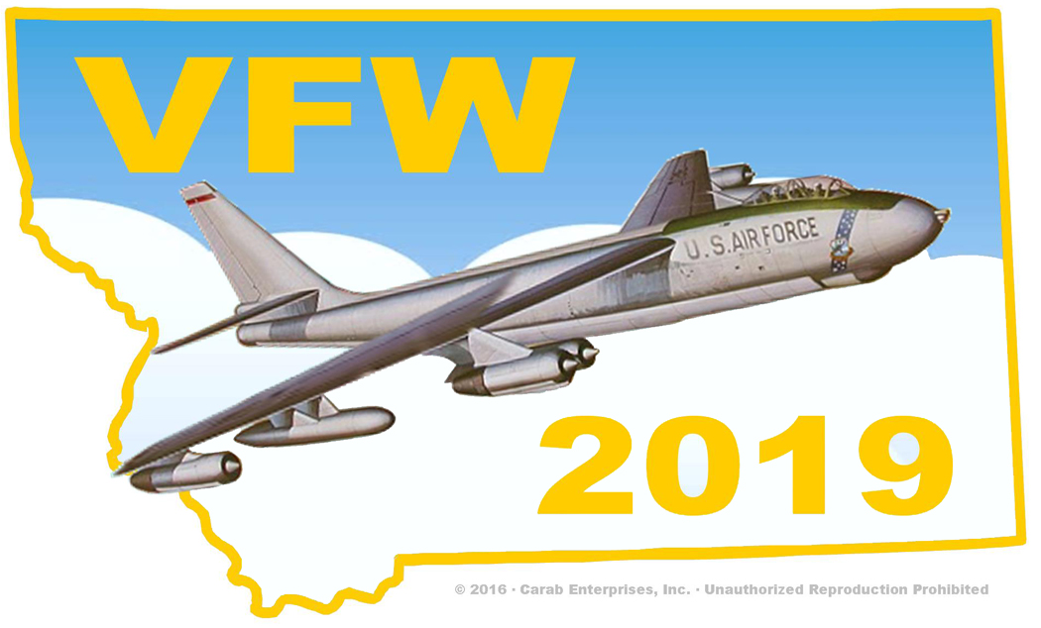

ALL-STATE DISTRICT COMMANDERS

The highest scoring District Commander, will be selected as All-State District Commander, Captain. And will receive a special All-State District Commanders Cap. If District is not 100% by April 30, 2019 but is 100% by June 30, 2019 The All-State cap will be presented at a later date as long as you qualify for All-State.

To qualify for All-State the District must complete the following

Each Post in the District MUST be inspected by 15 October 2019.

2. The following criteria and points will be used to determine the All State District Commanders.

District 100% Membership by June 30, 2019 Total 30 Points
Every Post in the District 100% by April 30, 2019 Total 100 Points
District 100% Inspected by October 15, 2018 Total 40 Points
District 100% Inspected after October 15, 2018 Total 20 Points
District 100% of Posts reporting in Community Activities
Programs by April 30, 2019 Total 80 Points
Districts 100% of Posts purchasing
Buddy Poppies by April 30, 2019 Total 30 Points

Grand Total 300 Points

NOTE: If you already own an All-State cap for this position you will be offered a special insignia, a Gold Star, to place on your current cap instead of receiving a new cap. This will allow the next Commander in line to receive his/her first cap. As can be deduced from above the Department will only purchase two (2) caps and unlimited Gold Stars. This does not limit the number of All-State District Commanders that may be recognized. If a District Commander qualifies for All-State but falls out of the two
All State Cap limits, however it will be required for the District Commanders / Quartermaster’s District to purchase an All-State cap if so desired. All-State Caps must be ordered through Department Headquarters.

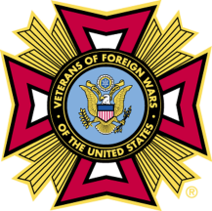

VFW National Membership Program
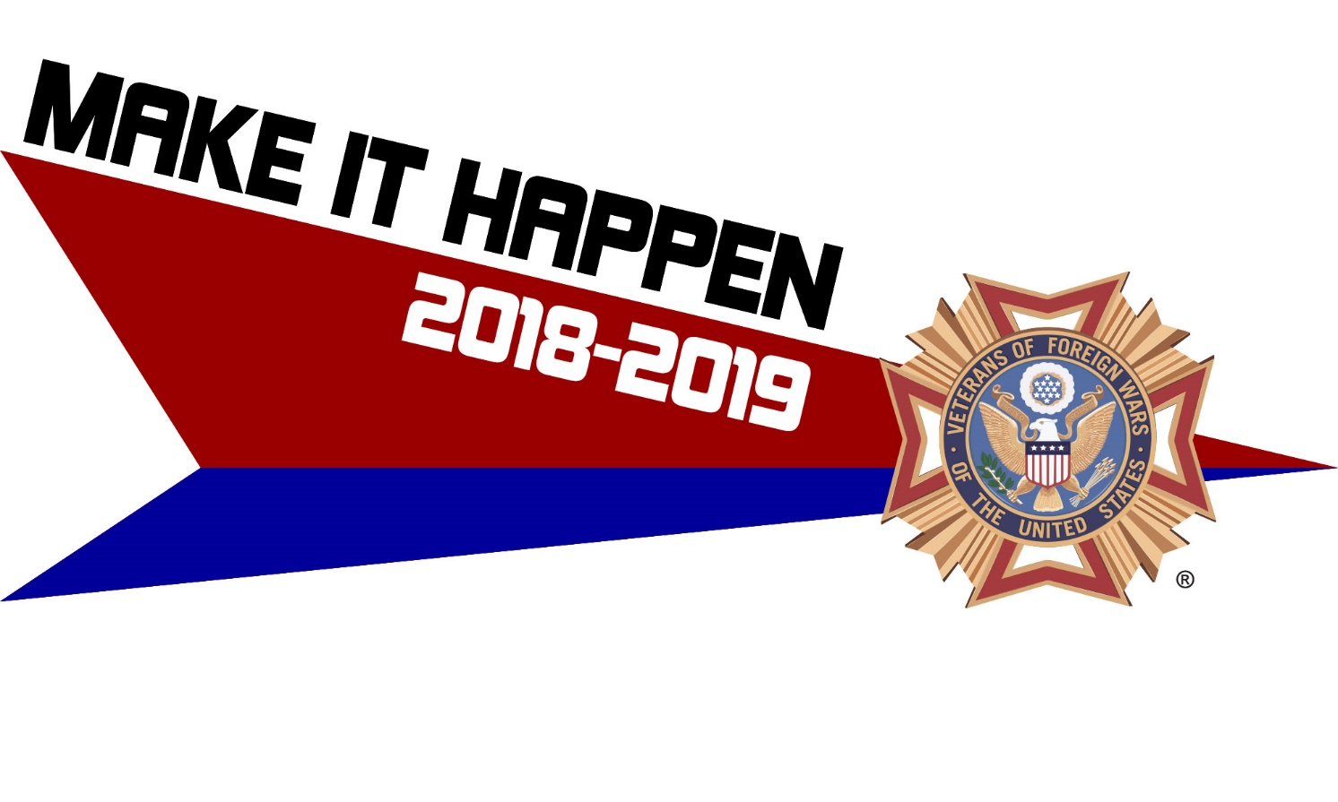

B. J. LAWRENCE
Commander-in-Chief

Membership Mission
To recruit, retain, and mentor a stable membership base, including all generations of veterans. To cultivate a membership that is well-versed in institutional knowledge and actively involved at all levels of the organization and in the local community. To establish Posts with a strong tradition of service, leadership, and community outreach.

Introduction
For the past several years, the VFW has been relatively successful in recruiting members aged 39 and younger. The only way to make this success permanent is to retain those members, recover past members, and recruit new members. We must improve the way we communicate with our members at all levels of the organization. Does your Post, District, State or Department have a newsletter, email, or an outreach team that visits fellow members? In many cases, we have lost touch with our members. We need to know who they are and what their needs are. Let’s get back to basics—our first priority is taking care of our members and the veteran community as a whole.

Membership Goals
- Build a strong organization for the future.
- Work together to achieve the VFW’s goals. The VFW National Headquarters staff is here to assist in coordinating programs, developing new membership initiatives and building awareness among our membership and the entire veteran community.

Membership Objectives
  - Recruit new and recover unpaid members
  - Retain and mentor existing membership
  - Develop new Posts and revitalize existing Posts
  - Increase Life Membership
  - Increase Legacy Life Membership

Retention Defined
Although retention is not a prerequisite for the All-American program, it is extremely important to understand how retention is derived and the important role retention plays in accomplishing growth. The number of paid annual members in your Post on July 1 is your ensuing year’s “prior year total.” One more new or reinstated member is required to make up for each prior year annual member the Post fails to retain.
Your Post retention is derived from six types of payment components based on your prior year total of annual members:
- A prior year annual member pays his or her annual membership dues.
- A prior year annual member pays the life membership installment fee.
- A prior year annual member pays for life membership dues.
- A prior year annual member transfers to another Post and pays his or her annual membership dues.
- A prior year annual member transfers to another Post and pays the life membership installment fee.
- A prior year annual member transfers to another Post and pays life membership dues.

Recruiting Awards

Individual Awards:
- 5, 10, 15 Corresponding numbered member pin
- 25 Commander-in-Chief membership coin & citation
- 50 VFW leather travel bag
- 75 Commemorative medallion set
- 100 Century cap and citation
- 175 National aide-de-camp cap and citation

“LUCKY STARS” Member Drawing
Five (5) winners will be drawn and accompany the Commander-in-Chief on an all-expense paid trip in May 6-12, 2019 to Costa Rica along with their spouse or guest.
For any new/reinstated member recruited between July 1, 2018 and April 01, 2019:
- You will receive one (1) chance for every five (5) new/reinstated members recruited
- You will receive ten (10) additional chances for every increment of 25 new/reinstated members recruited
- Attention Post and District Commanders:
- You will receive ten (10) chances in recognition of 85%+ post and district retention
Drawing will take place April 2, 2019
- All awards are non-transferable

Department “First to Finish” Incentive
The Department Commander and Quartermaster along with a guest for each of the Department that is the first to attain 100% in membership will be awarded.
- Round trip airfare, accommodations and transportation with transfers. To include three nights in Honolulu and four nights in Maui, Hawaii. Note: if Hawaii wins, CDR and QM with guest will win a trip of equal value.

Early Bird Award—VFW Legislative Conference
The top three Post commanders and quartermasters and the top two District commanders in each division on Jan. 1, 2019 will be awarded:
- A $1,000 stipend to be used toward attending the VFW Legislative Conference, Washington D.C.

Department Quartermaster Early Bird Incentive
For every Department that achieves 92% in membership by Jan 1, 2019; the Department Quartermaster will receive:
- A Henry 30-30 Caliber Rifle or a credit voucher of equal value, for use with Veterans Travel Service.

Post Commander and Quartermaster – New & Reinstated Member Award
The top 10 Post commanders and quartermasters in each division who report more than 50 new and reinstated annual members by Jan. 1, 2019 will each be awarded:
- A travel charger with the official VFW Commander-in-Chief logo.

Kansas City Spree
The top two Post commanders and the top two District commanders in each divisions who achieve 100% membership by April 1, 2019 along with their spouse or guest, will be awarded:
- Round-trip airfare to Kansas City, Mo, from the airport nearest the awardee’s home.
- A fun-filled weekend (May 16-19, 2019) that may include but is not limited to: touring, shopping, and a complete tour of the VFW National Headquarters.

100% Post, District & Department
A distinctive streamer will be awarded to every Post, District and State/Department that achieves 100% or greater in membership before July 1, 2019.

100% Commander Drawing
Each Post and District commander that exceeds 100% in membership by June 1, 2019 will be placed in a drawing. 20 post commanders and 12 district commanders will be drawn to receive:
- A $1,000 stipend to be used toward attending the VFW National Convention.

Post Commander and Quartermaster Division Challenge
For every ten (10) new/reinstated members recruited between July 1, 2018 and April 1, 2019; Posts will earn one chance for both Post Commander and Quartermaster to be entered into a drawing. One Post per Division will be drawn to receive:
- A $1,000 stipend each for Commander and Quartermaster to be used toward attending the VFW National Convention.

Legacy Life Membership Acquisition
Each Post that achieves the designated benchmarks of 25, 50 and 75 Legacy Life Members will be awarded:
- A Legacy Society Post Proclamation.
Each Post that achieves the distinctive benchmark of 100 Legacy Life Members by July 1, 2019, Commander or post representative will be awarded:
- A $1,000 stipend to be used toward attending the VFW National Convention.
- Reserved seating at the VFW National Convention joint opening session.
- Legacy Society Post Proclamation.

Elite Recruiter
Any VFW member who signs up 250 or more new and/or reinstated annual members by July 1, 2019, will be awarded:
- A $1,000 stipend to be used toward attending the VFW National Convention.
- Distinctive cap, citation, and name badge.

Recruiter of the Year
The VFW member who signs up the greatest number of new and/or reinstated annual members greater than 250 by July 1, 2019, will be awarded:
- A $1,000 stipend to be used toward attending the VFW National Convention.
- Reserved seating at the VFW National Convention joint opening session.
- Distinctive cap, citation, and name badge.
- Commander-in-Chief’s Crystal Eagle.

New Post Development Department Award
For each new Post chartered, the Department will receive:
- A $250 credit from the VFW Store to be used towards necessary materials for the new Post.

All-American Leadership Criteria
The All-American leadership program exists to recognize exceptional leadership, authentic accomplishment in membership growth and VFW core programs.

All-American Post Leadership Criteria
- Greater than 50 members on July 1, 2019
- Membership greater than 100%
- Finish in the top 50 posts in your respective division
- Voice of Democracy - minimum of one entry advanced to District Judging (Overseas Post donate $50 to National in lieu of entry)
- Patriots Pen - minimum of one entry advanced to District judging (Overseas Post donate $50 to National in lieu of entry)
- National Citizenship Education Teachers Award – one entry advanced to District judging (Overseas Post donate $50 to National in lieu of entry)
- Buddy Poppy- must purchase Buddy Poppies
- Hold a fundraiser with the proceeds going to National Veterans & Military Support Services, minimum of $50
- National Veterans Service – Appoint a Post Service Officer

All-American Post Leadership Award
- Acknowledgment in VFW Magazine
- All-American Post citation
- All-American Post streamer
- All-American citation - Commander
- All-American name badge - Commander
- All-American cap - Commander - *Quartermaster may purchase cap
- All-American lapel pin - Commander - *Quartermaster may purchase pin
- The top five Commanders in each division will also receive:
  - A $1,000 stipend to be used toward attending the VFW National Convention.
  - Reserved seating at the VFW National Convention joint opening session.

All-American District Leadership Criteria
    - Membership greater than 100%
    - Finish in the top 25 Districts in your division
    - Voice of Democracy - minimum of one entry advanced to Department Judging (Overseas District donate $100 to National in lieu of entry)
    - Patriots Pen - minimum of one entry advanced to Department judging (Overseas District donate $100 to National in lieu of entry)
    - National Citizenship Education Teachers Award – one entry advanced to Department judging (Overseas District donate $100 to National in lieu of entry)

All-American District Leadership Award
- All-American District streamer
- All-American District citation - Commander
- All-American name badge - Commander
- All-American cap - Commander - *Quartermaster may purchase cap
- All-American lapel pin - Commander - *Quartermaster may purchase pin
- The top two District Commanders in each division will also receive:
  - A $1,000 stipend to be used toward attending the VFW National Convention.
  - Reserved seating at the VFW National Convention joint opening session.

All-American Department Leadership Criteria
- Membership must be greater than 100%
- Must conduct two Membership Recruiting events prior to May 1, 2019. A report of these events should be submitted to the Membership Department.
- Hold a Commander’s Round-Up* prior to January 1, 2019 with a report submitted to the Membership Department.
- One new post or increase the membership of three posts of 50 members or less to over 50 members by July 1, 2019
- National Legislative Service
  - Monthly National Legislative Service committee member/chairman reports must be submitted to National Legislative Service in Washington, D.C.
- National Veterans Services
- Must have a State/Department service officer and submit his or her name and contact information to National Veterans Services in Washington, D.C. by July 31, 2018
- Monthly National Veterans Services committee member/chairman reports must be submitted to National Veterans Services in Washington, D.C.
- Programs
  - Voice of Democracy - An entry advanced to national judging
  - Patriot’s Pen - An entry advanced to national judging
  - National Citizenship Education Teacher Award – submit an entry in all three categories (K-5, 6-8, 9-12) and entries must advance to national judging
  - Veterans & Military Support Programs – Must complete a State/Department fundraiser and proceeds must be donated to: Veterans & Military Support Programs, Kansas City, MO
  - Student Veterans of America (SVA)
- Select a state/department SVA liaison, and submit their contact information to the VFW Programs Department, no later than July 31, 2018.

All-American Department Leadership Award
- All-American Department streamer
- All-American Department citation - Commander
- All-American name badge - Commander
- All-American cap - Commander - *Quartermaster may purchase cap
- All-American lapel pin - Commander - *Quartermaster may purchase pin
- $1,000 stipend to be used toward attending the VFW National Convention
- Reserved seating at the VFW National Convention joint opening session

Conference Membership Award
The state/Department leading each conference will be entrusted with the conference membership colors for the following year. The 2018-2019 Conference winners will pick up the colors from the Membership Department at National Convention in Orlando, FL.
The Conference with the highest membership percentage of the four Conferences will have their name and year engraved on a traveling trophy that will be presented by the Commander-in-Chief to the Conference Chairman at the National Convention. This trophy will be entrusted to the Conference until the following National Convention.

Post Membership Divisions and Minimum Qualifying Percentages
Division | Total Membership |  | Qualifying Percentage | # Eligible
1 | 750 | And up! | Over 100% | 50
2 | 356 | 749 | Over 100% | 50
3 | 246 | 355 | Over 100% | 50
4 | 185 | 245 | Over 100% | 50
5 | 143 | 184 | Over 100% | 50
6 | 112 | 142 | Over 100% | 50
7 | 88 | 111 | Over 100% | 50
8 | 68 | 87 | Over 100% | 50
9 | 51 | 67 | Over 100% | 50
10 | 1 | 50 | Over 100% | 50

District Membership Divisions and Minimum Qualifying Percentages
Division | Total Membership |  | Qualifying Percentage | # Eligible
1 | 5,000 | 14,000 | Over 100% | 25
2 | 3,282 | 4,999 | Over 100% | 25
3 | 2,172 | 3,281 | Over 100% | 25
4 | 1,447 | 2,171 | Over 100% | 25
5 | 906 | 1,446 | Over 100% | 25
6 | 1 | 905 | Over 100% | 25

IMPORTANT NOTES
- To receive stipends, awardees must be in attendance at designated events
- Only one National paid stipend per event (national convention, legislative conference, etc.)
- All awards are non-transferable
- The Commander’s Round-Up program is for Department Commanders to visit Posts in their Department to get face-to-face time with their Post and District leadership and assist with membership development events. For further information about the Commander’s Round-Up, please contact the Membership Department.

