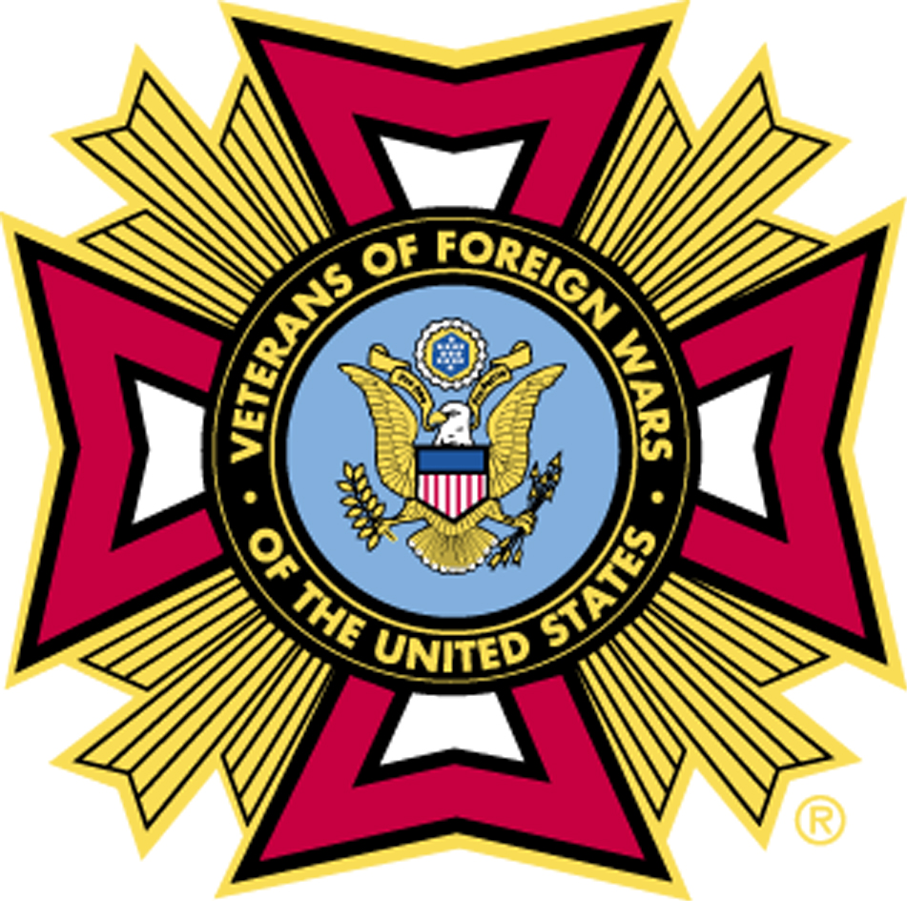
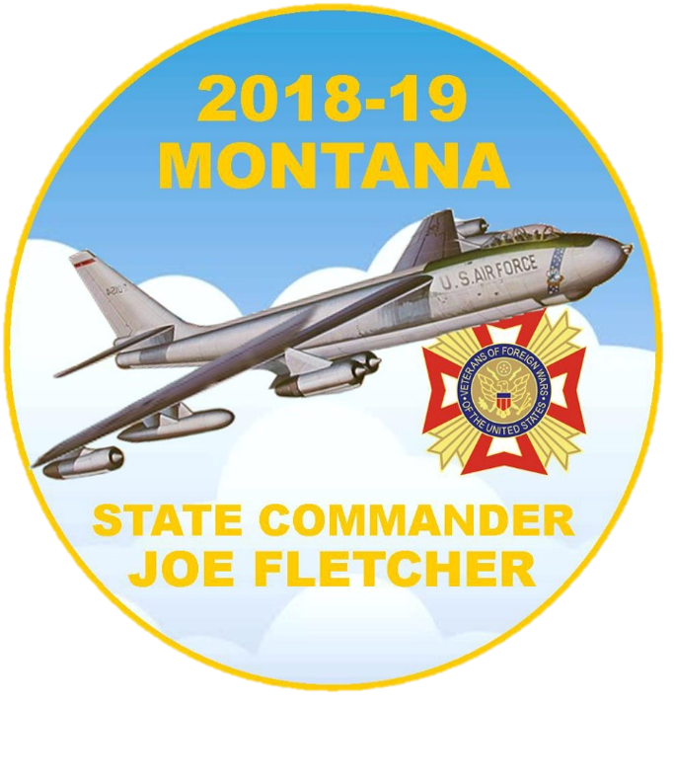
DEPARTMENT OF MONTANA
VETERANS OF FOREIGN WARS
97th STATE CONVENTION
JUNE 12, 13, 14, & 15, 2019
LIBBY, MONTANA

WEDNESDAY, JUNE 12

1500-1600 MOC REGISTRATION – VFW Post 1548
1600-2000 REGISTRATION – VFW Post 1548
1600-1800 MOC “GRAND” SCRATCH – VFW Post 1548
1900 COUNCIL OF ADMINISTRATION – VFW Post 1548

THURSDAY, JUNE 13

0800-1600 REGISTRATION – VFW Post 1548
0900 JOINT OPENING SESSION – VFW Post 1548
1200 LUNCH – ON YOUR OWN –
1200-1330 PAST DEPT. COMMANDER LUNCHEON – 4B’S
1330-1630 VFW TRAINING – Ponderosa Room at City Hall
1700 DEPT. SR VICE COMDR AND PRES.'S RECEPTION – Riverfront Park

FRIDAY, JUNE 14

0800-1600 REGISTRATION – VFW Post 1548
0900 FIRST BUSINESS SESSION – Ponderosa Room at City Hall
1200 LUNCH - ON YOUR OWN -
1330-1600 SECOND BUSINESS SESSION – Ponderosa Room at City Hall
1700-1800 NO-HOST COCKTAIL HOUR – VFW Post 1548
1800 AWARDS BANQUET – VFW Post 1548

SATURDAY, JUNE 15

0800-0900 REGISTRATION – VFW Post 1548
0900 THIRD BUSINESS SESSION – NOMINATIONS, - Ponderosa Room
CAUCUS - TBD
1000 ELECTION & INSTALLATION OF OFFICERS – Ponderosa Room
1100 COUNCIL OF ADMINISTRATION MEETING – Ponderosa Room

HAVE A SAFE TRIP HOME

